Nabi Nurdaulet

Laboratory Work 5: Table Constraints and Modifications in PostgreSQL

Subject: Database Management Systems

Topic: CHECK, UNIQUE, DEFAULT Constraints and Table Alterations

1. Objective

The objective of this laboratory work is to learn how to alter existing table structures and enforce data integrity by applying various constraints (`CHECK`, `UNIQUE`, `DEFAULT`) and default values in PostgreSQL.

2. Tasks & Execution

Task 1: Add a CHECK constraint to passenger table to provide that passengers must be at least 10 years old
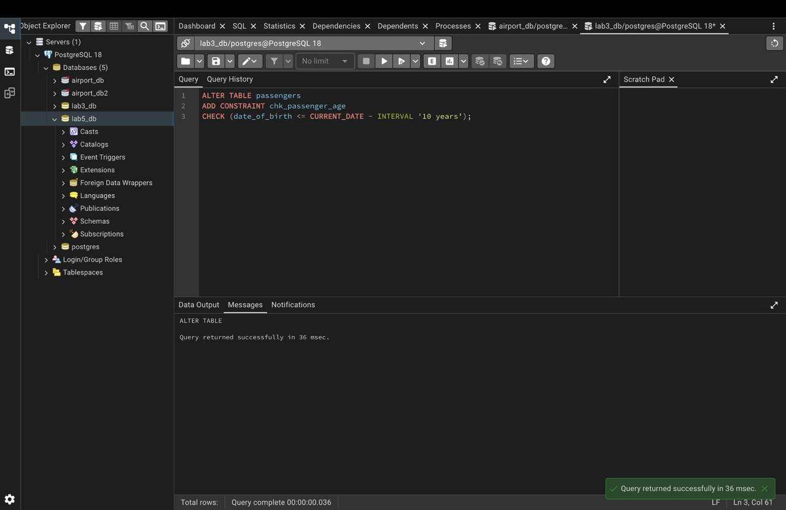

Task 2: Add a CHECK constraint to accept values in booking price not more than 50000 and less than 0
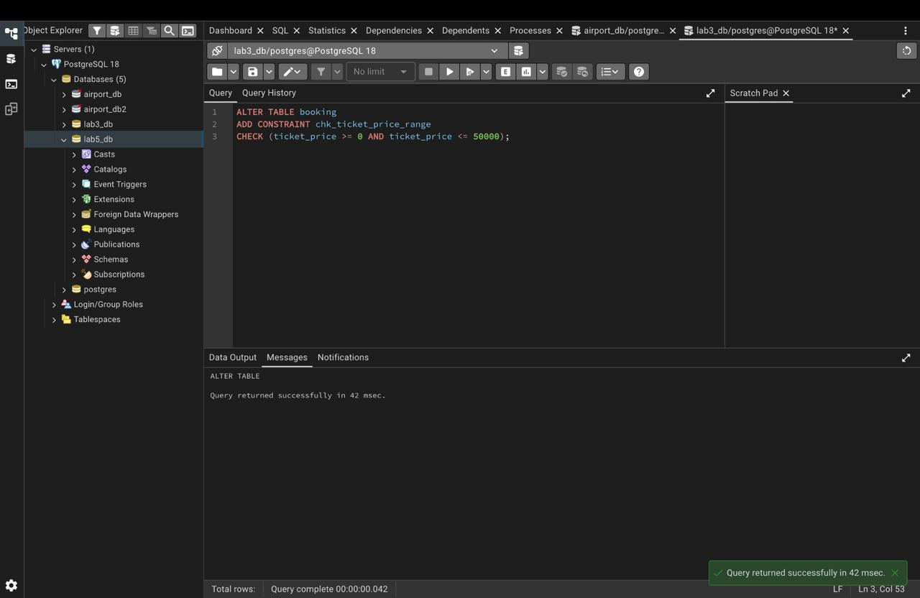

Task 3: Add a CHECK constraint to accept the luggage weight between 1 and 23 kg
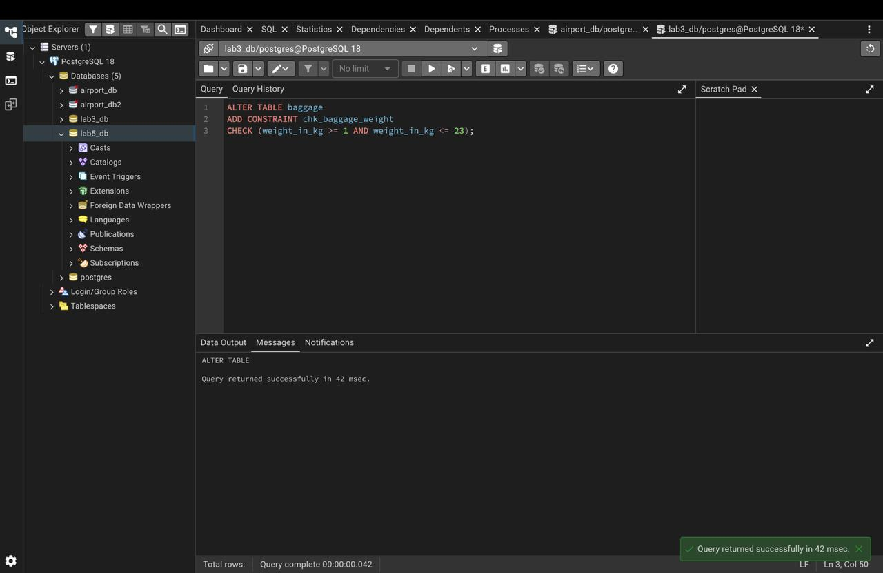

Task 4: Add a CHECK constraint to ensure that all values in airport_name must have at least 10 characters
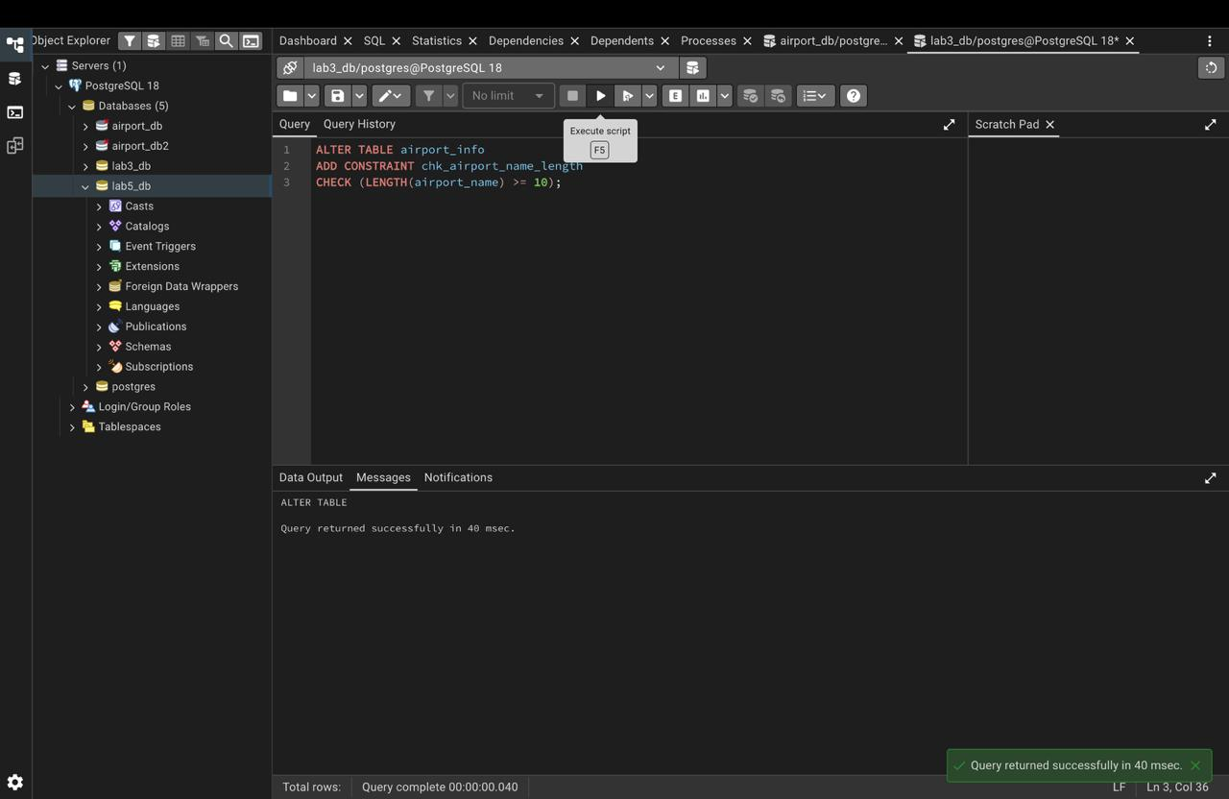

Task 5: Add UNIQUE constraint to some columns in each table in database
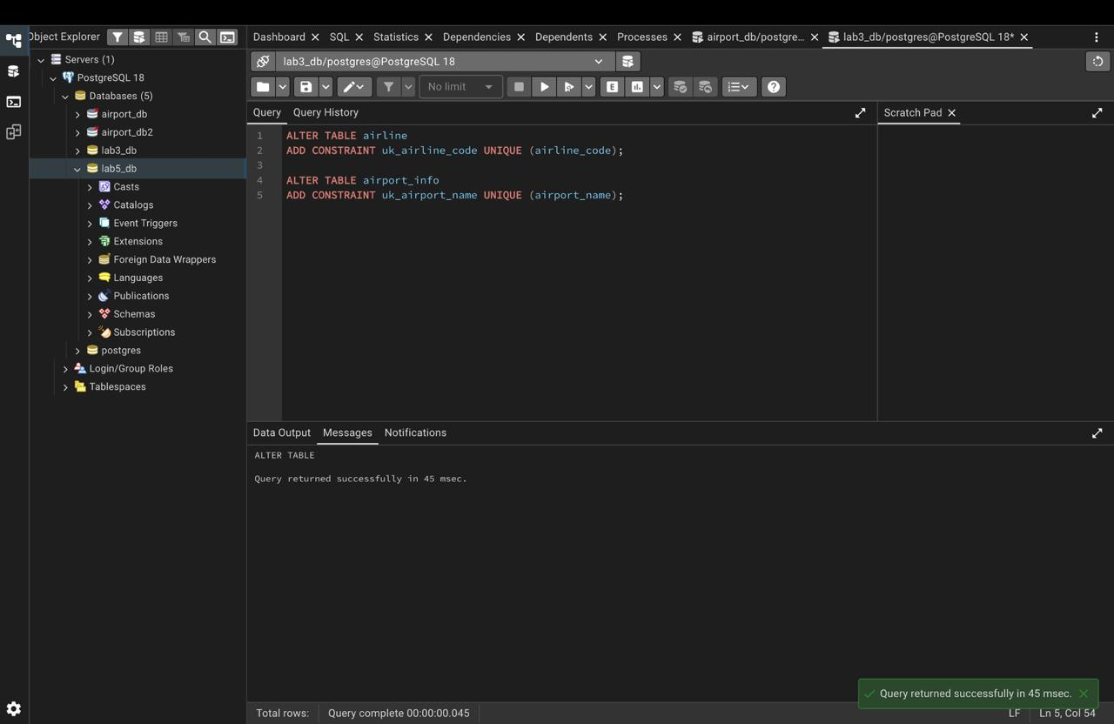

Task 6: Add a CHECK constraint to ensure that male passengers must be at least 18 years old and female passengers must be 19 years old
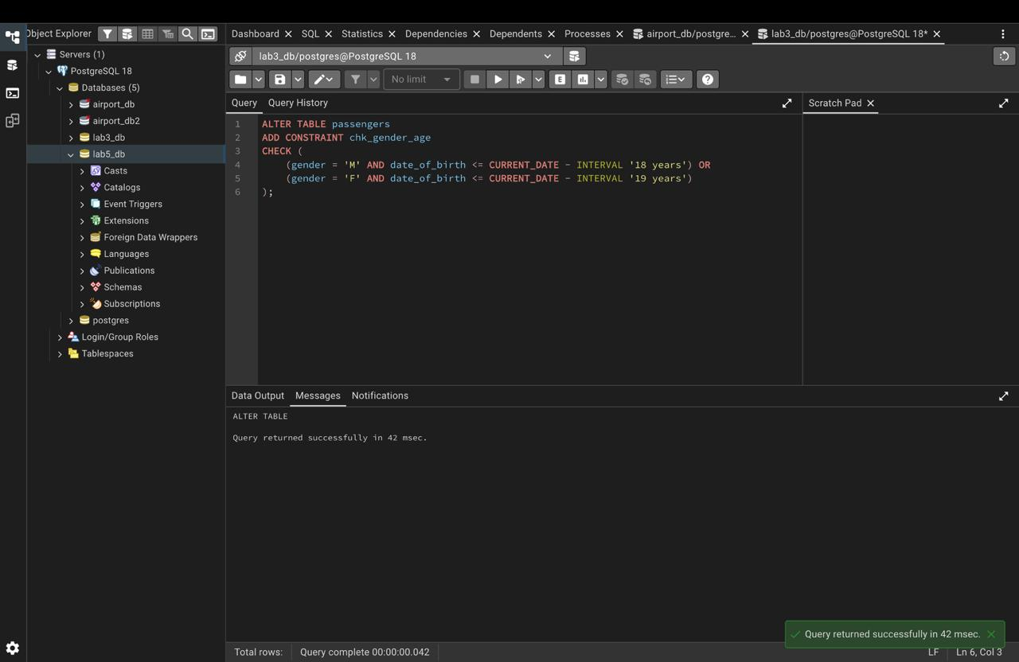

Task 7: Add a CHECK constraint based on country_of_citizenship for age limits
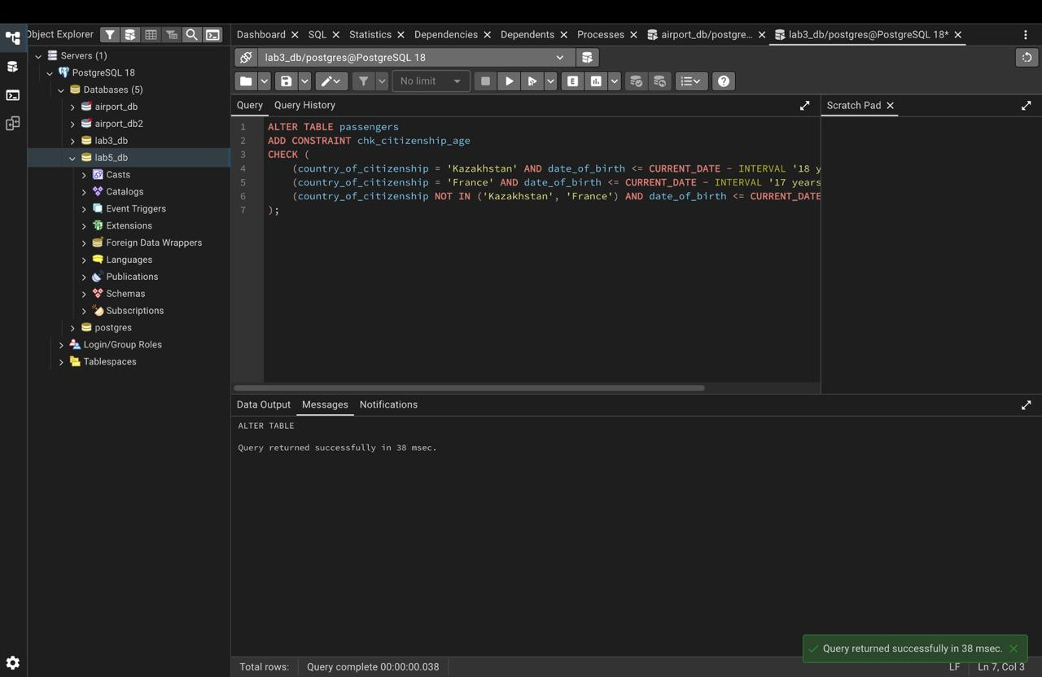

Task 8: Add a ticket_discount column and a CHECK constraint based on price and creation date
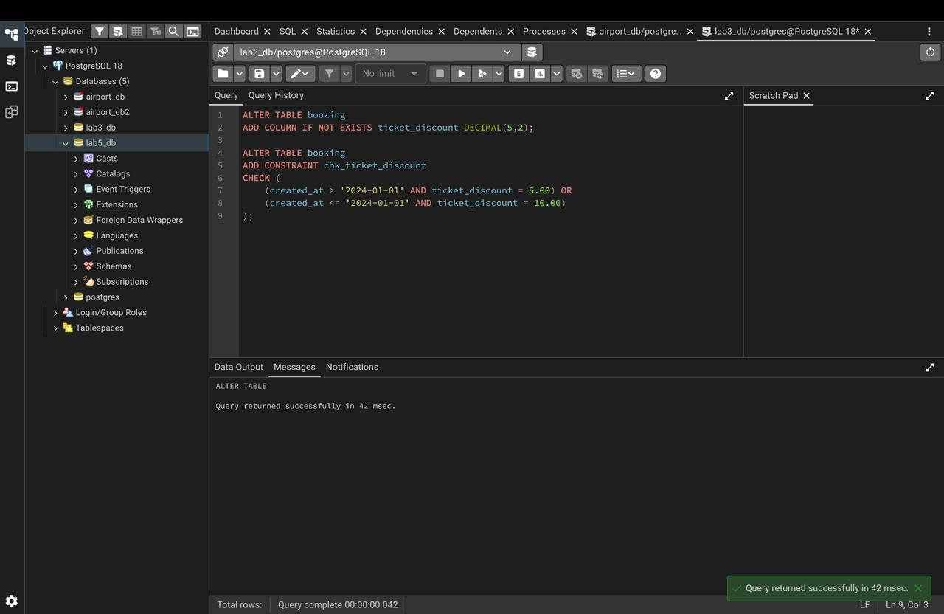

Task 9: Modify booking status column to have a default value of 'Confirmed' and insert a row
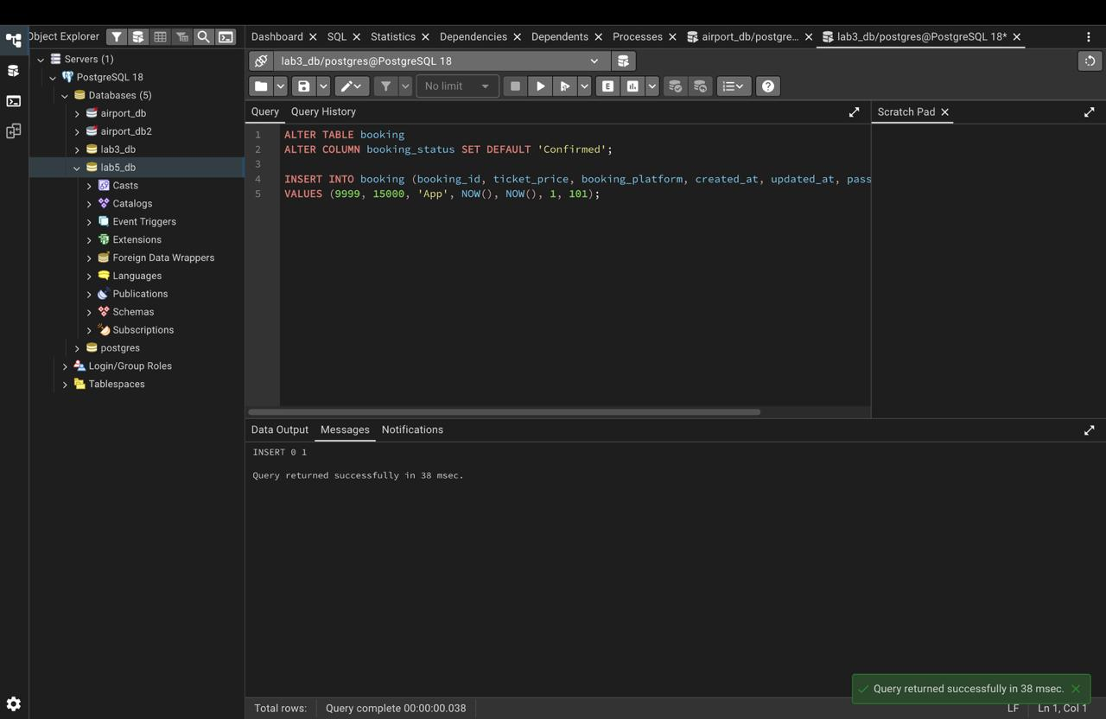

Task 10: Modify date column to automatically set the current date on insert
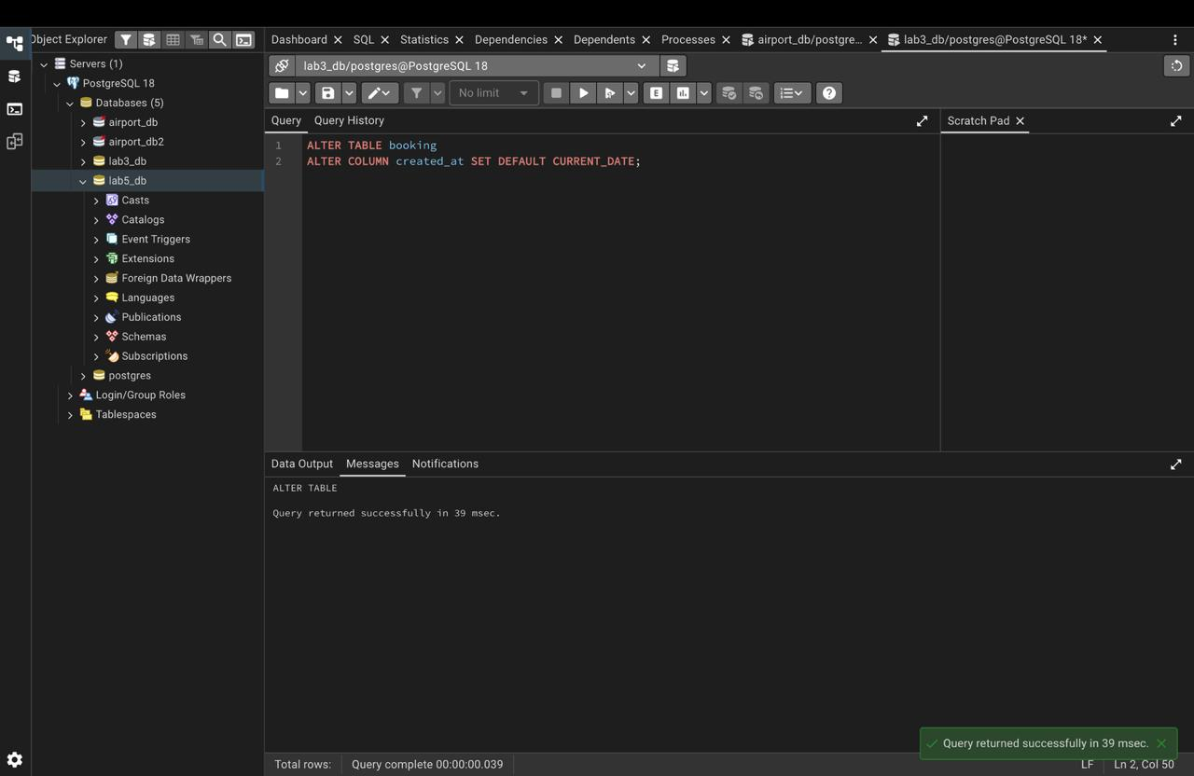

3. Conclusion
In this laboratory work, database constraints (CHECK, UNIQUE, DEFAULT) were successfully implemented to enforce business logic rules and data integrity directly at the database level.

